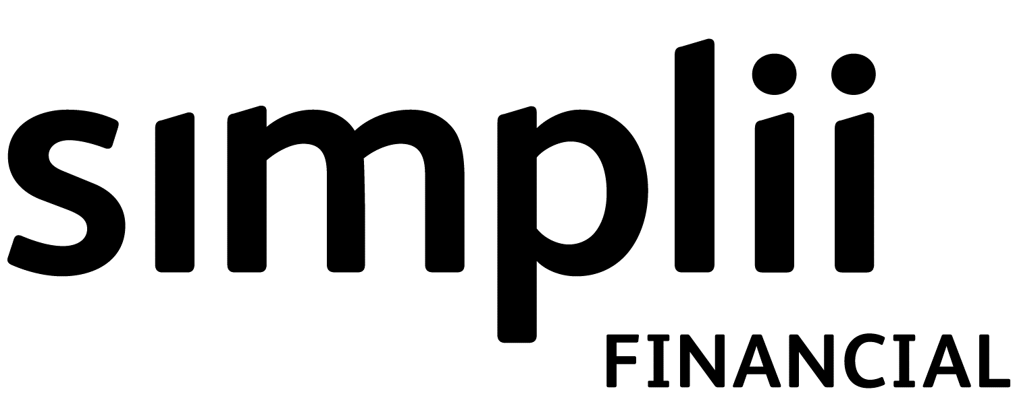

# Simplii FinancialTM Up to 5% Cash Back Offer

**Transaction Type:**  **New Business**  **Renewal**  **Early Renewal**

|  |  |  |
| --- | --- | --- |
| Mortgagor’s Name(s) |  |  |
|  |  |  |
| Mortgage No. | Term & Cash Offer Selected | Date (month/day/year) of signing this coupon |

We would like to thank you for your business; the Cash Back Amount noted above is yours to spend however you wish. If you will be represented by a solicitor in completing this mortgage transaction, the Cash Back Amount will be paid to your solicitor “in Trust”. Otherwise we will deposit the Cash Back Amount into your bank account noted below within 30 days after the transaction is completed.

This Cash Back Offer is subject to the terms and conditions set out in this coupon. If there is any discrepancy between the provisions of this coupon and the provisions of any mortgage document, including but not limited to the registered mortgage, Standard Charge/Mortgage Terms, Mortgage Disclosure Statement, Renewal Agreement, Transfer-in Agreement, Commitment or Mortgage Approval, then the provisions of this coupon shall prevail. This applies whether the other mortgage documents are signed or dated before or after you sign this coupon.

By signing this Coupon, you agree that if any of the terms and conditions of the mortgage are amended, or if the mortgage is discharged, paid out, transferred by us at your request, assigned, refinanced, ported, assumed, converted or early renewed prior to its maturity date for any reason, or if the property is sold under power of sale or foreclosure, **you will repay to us the entire Cash Back Amount set out above**.

In addition, if you receive any Cash Back Amount following the commencement of a renewal, early renewal or conversion application and the application is not finalized for any reason, you will immediately repay to us the entire Cash Back Amount received.

Your obligation to repay the Cash Back Amount set out above is separate from any of the prepayment charges, other charges or fees applicable to the mortgage. You must repay the Cash Back Amount to us at the time of amendment, discharge, payout, transfer, assignment, refinance, port, assumption, conversion, early renewal or sale under power of sale or foreclosure. If you do not, at our sole option, we may declare that you are in default on the mortgage, or we may add the Cash Back Amount to the principal amount owing under the mortgage and it will bear interest at the mortgage rate, or we may do both.

**All information must be completed in full or this coupon cannot be redeemed. All borrowers and guarantors must sign this coupon, and a signed copy of this coupon must be given to each borrower and guarantor. Please print clearly.**

**Customer Account Information** (only required for transactions that will not be completed by the borrower’s solicitor)

I would like my Cash Back Amount deposited in (please select one of the following):

Current account linked with this mortgage

Other account (attach void cheque and fax back number below or fill in the information below)

|  |  |  |
| --- | --- | --- |
| Institution No. | Transit No. | Account No. |
|  |  |  |

I/We understand and agree to all terms and conditions of this Cash Back Offer and to the payment of the Cash Back Amount to my/our solicitor in trust, or deposit of the Cash Back Amount into the account noted above, as applicable. By signing below I/we confirm that each of us has received a copy of this Cash Back Offer and retained a copy for our records.

|  |  |  |  |  |
| --- | --- | --- | --- | --- |
|  |  |  |  |  |
| Mortgagor Signature |  | Co-Mortgagor Signature (if any) |  | Co-Mortgagor Signature (if any) |
|  |  |  |
| Date (month/day/year) |  | Guarantor Signature (if any) |  | Guarantor Signature (if any) |
|  |  |  |  |  |
| Mortgagor Representative |  |  |  |  |

Upon approval of the mortgage, immediately return this Cash Back coupon to CIBC at the fax number below. If you have any questions on the status of the coupon call the number below.

|  |  |
| --- | --- |
| Telephone No. | Facsimile No. |
|  |  |

## Conditions of Eligibility

Mortgage financing through Canadian Imperial Bank of Commerce ( CIBC). This Offer replaces and cannot be combined with any other bonuses and offers. Outstanding mortgage principal on date of advance, renewal, early renewal or conversion, must be $35,000 or greater to be eligible for this Offer. The maximum Cash Back Amount is 5% of the outstanding mortgage principal. Usual lending criteria apply. Offer not transferable and is available only to Simplii Financial residential mortgage customers approved for a 5, 7 or 10 year closed, fixed-rate mortgage. Only one Offer per mortgage term. For transfers-in, mortgage must be a lender that is approved by CIBC and charges from your existing lender may apply. Assumptions and ports of current mortgages do not qualify for the Cash Back Offer. Cash Back must be taken as offered and this certificate has no cash value.

**Issue of this coupon is strictly within the discretion of CIBC. CIBC reserves the right to limit the use of this coupon. CIBC has the right to cancel this Up to 5% Cash Back Offer at any time.**